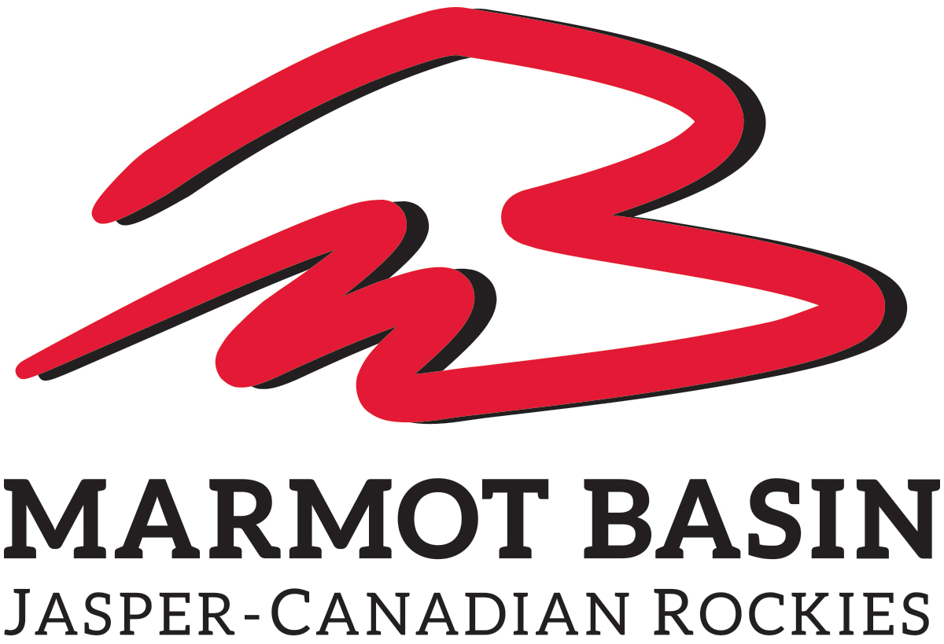

MARMOT BASIN
HIGH PERFORMANCE SKIS FOR SALE

Skis | Lengths | Price
Head SuperShape i.Magnum | 156/163 | $560
Head SuperShape i.Rally | 163/170/177 | $560
Head REV 80 Pro | 177 | $500
Fischer Nightstick | 181 | $233
Fischer Pro MTN 86 Ti | 168 | $350
Fischer Curv DTX | 164/171 | $560
Fischer Curv Ti | 164/171 | $420
Fischer Curv GT | 168 | $560
Fischer My Curv Allride | 157/164/171 | $420
Fischer Pro MTN 74 | 165 | $250
Rossignol Famous 6 Light | 156 | $250
Rossignol Sprayer | 138 | $210
Rossignol Experience 84 | 162/178 | $430

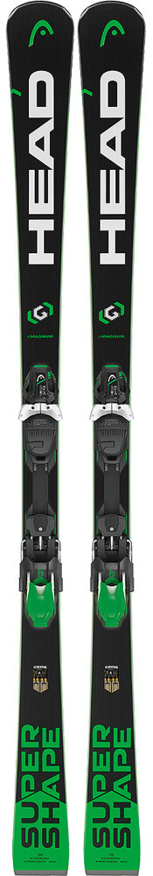
Head i Magnum
A smooth ski that is great for skiing primarily on-piste. The technology within these skis help to dampen the bumps while on groomers and helps the ski stay in control.
The wide shovel tip is great if conditions get slushy at the end of the day, as well as if you get caught in some powder.
The core is made of wood with a titanium sheet, but also includes a sheet of graphene to keep it light.
131-72-110
Lengths Available: 156/163

$560

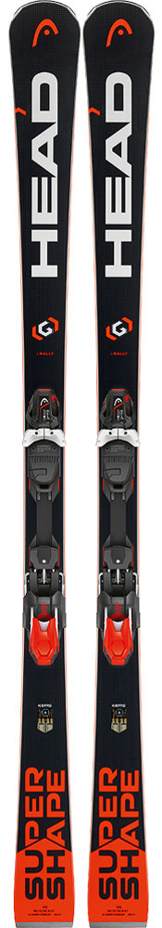
Head i Rally

A great carving ski with a short, snappy turn radius. Most appropriate to use on firmer snow and meant for a skier with strong legs that wants to ski piste all day.
The rockered tip allows you to enter any turn at any speed with incredible ease, gripping early both long and short radius turns.
The tips have a decent width that helps to cut up the heavy snow and moguls.
The core is made of Graphene World Cup construction which helps to build a lot of torsional stiffness into the ski.

135-76-114
Lengths Available: 163/170/177

$560
Head REV 80 Pro

The Head REV 80 Pro is a versatile all-mountain ski made for individuals who like to spend their time mainly on-piste and occasionally venturing into deeper snow.
They are easy to initiate into a turn and then manage to hold a fantastic edge right through the carve, with a small transition into the next turn.

130-81-112
Length Available: 177

$500

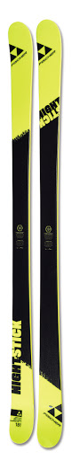
Fischer Nightstick
If you aspire to be a professional terrain park legend, you’ll want these skis in your possession. A symmetrical twin tip shape allows for easy riding both forward and switch, allowing you to expand your bag of tricks.
With a core constructed of poplar wood, this ski still manages to be lightweight.
Additionally, a sheet of metal in between increases the ski’s torsional rigidity.
114-84-114
Lengths Available: 181

$233
Fischer Pro MTN 86 Ti

The Pro MTN 86 Ti is an excellent and forgiving all-mountain ski with easy turn initiation and excellent response. It handles well in all on-piste, hard snow situations while still providing a thrilling sense of absolutely control at higher speeds.
While is does lack in floatation, it makes it up with its stability, carving pleasure, and turn shape variability.
128-86-116
Lengths Available: 168

$500
Rossignol Famous 6 Light
With a light-wood core and pro-tip technology, the Famous 6 Light is a lightweight ski that gives a smooth, beautiful ride. A very easy ski to ride with a great edge grip, meaning you can really enjoy those long carving turns on the slopes.
A stable ski that is a great option for anyone looking to improve their skis.
126-74-110
Lengths Available: 156

$250
Rossignol Sprayer
With a small underfoot, the ski is super light and maneuverable for airborne tricks. Stable at speeds but with lots of energy and pop, they are very playful and ensure solid landings. Excellent for the park with twin tips, this is an entry-level model for the park enthusiast.
110-80-103
Lengths Available: 138

$210

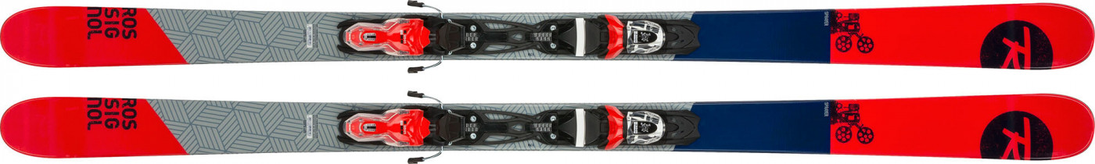

Rossignol Exp. 84
Make every day the best day of the season with the Rossignol Exp. 84.
With an all-terrain rocker, these skis perform well with hard snow precision and soft snow playfulness.
Whether you are hitting the groomers or exploring off piste, these skis are fast and fun, and hold up for an excellent all-mountain ride.

126-84-116
Lengths Available: 162/178
$430

Fischer Curv Allride
This ski is meant for an individual who wants to go fast all day long. With its combination of power, smoothness, stability, and quickness it makes an excellent carving ski for high intermediates to advanced skiers.
It has a very stiff tail that finishes turns powerfully, but it is not a demanding ski that punishes slight mistakes.
Many skiers found that they didn’t mind the ski on a slushy mogul day or on chalky, off-piste terrain – and feels quite versatile on the mountain despite it being intended for carving.
120-70-105
Lengths Available: 157/164/171
$420

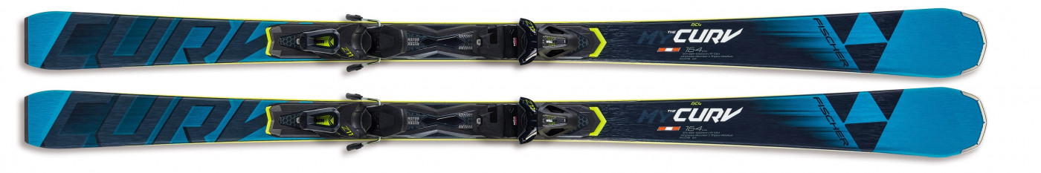

The Curv Ti
Another stunning carving ski that has an equal balance of smoothness, stability, and quickness, making it one of Blister Reviews favourite skis.
It has a very stiff tail that finishes turns powerfully, but is not a ski that punishes slight mistakes.

Not only does this ski loves long, flowy t urns – but it also is comfortable making shorter, quicker turns.

121-68-102
Lengths Available: 164/171
$420

The Curv DTX
Reviewed by many, the consensus is that this ski has an excellent edge hold and is easy to turn in long turns.

This is the perfect ski for individuals that want to carve and push hard all day long.
Excellent for piste conditions in terms of speed, stability, responsiveness, incredible edge hold, and the ease of turning.
121-70-105
Lengths Available: 164/171
$560

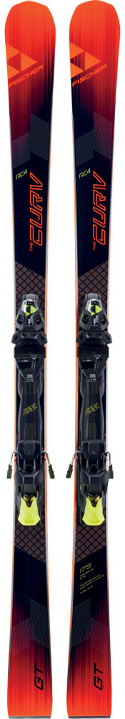
The Curv GT
The Curv GT is a great ski, with a nice mix of power, authority, and finesse. It owns the short and medium carve, with an ability to drive right into some remarkably solid edge grip.
With a stiff tail, this ski better at shorter turns than it is in a long radius.

130-78-113
Lengths Available: 168
$560

Pro Mtn 74
The Fischer Pro Mtn 74 is a smooth and forgiving ride perfect for intermediate skiers.
Considered to be an all-mountain ski – it prefers groomed runs over fresh powder due to its medium-width waist.

120-74-102
Lengths Available: 165
$250

